**ABHISHEK SHARMA**

**R171218005**

**DEVOPS B-1**

**ADVANCED LINUX LAB FILE (2.13)**

**Network Management and Debugging**

**Commands To Run: -**

**$ ping google.co.in**

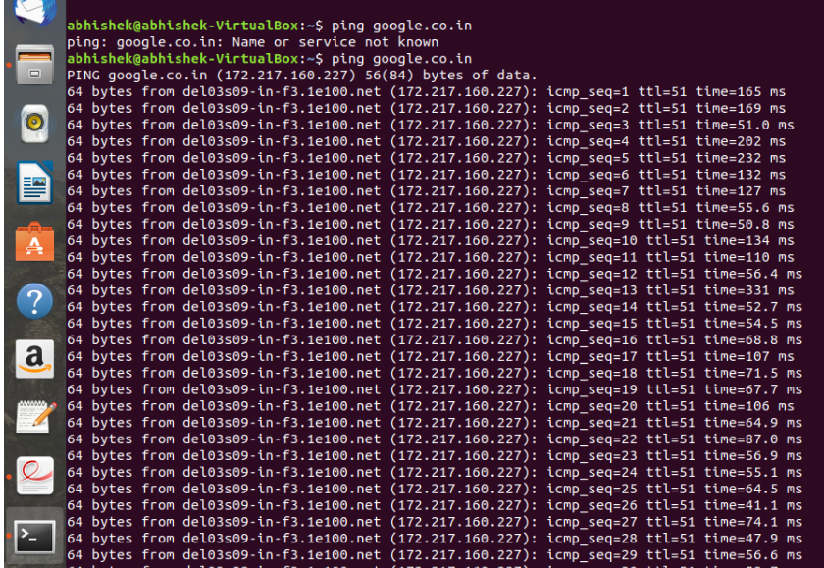

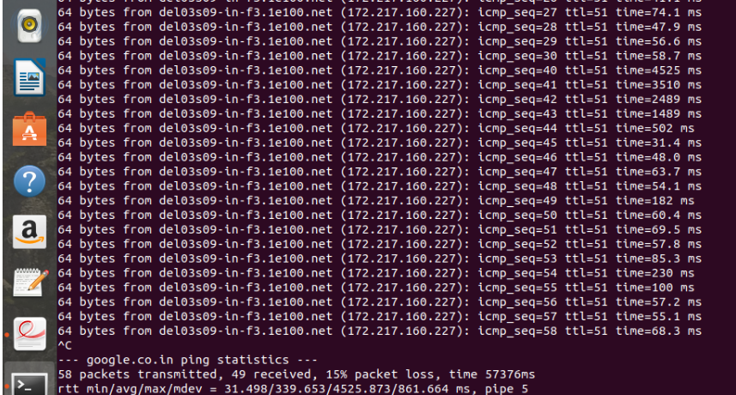

**$ ping -s 300 google.co.in**

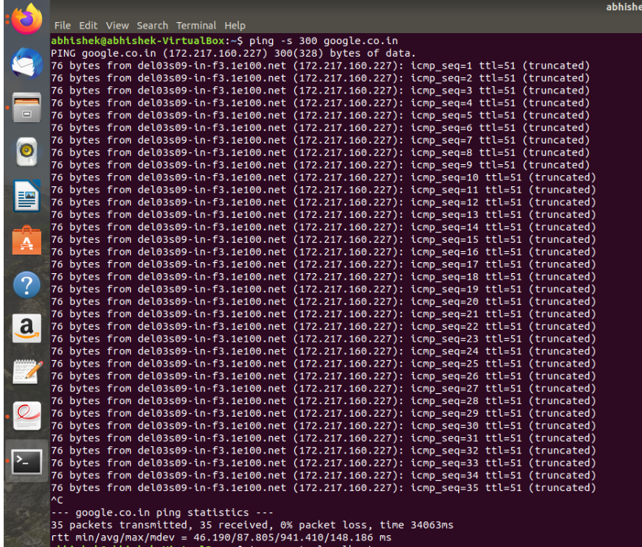

**$traceroute localhost**

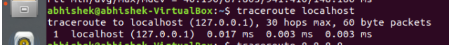

**$traceroute 8.8.8.8**

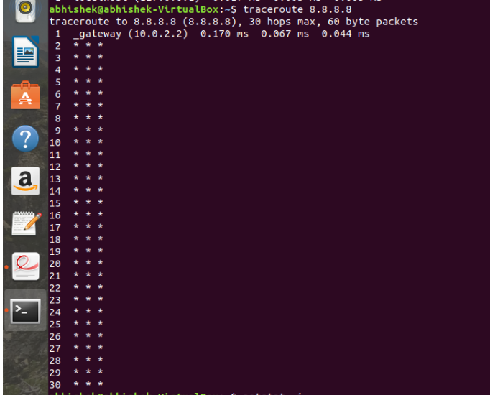

**$ netstat –i**

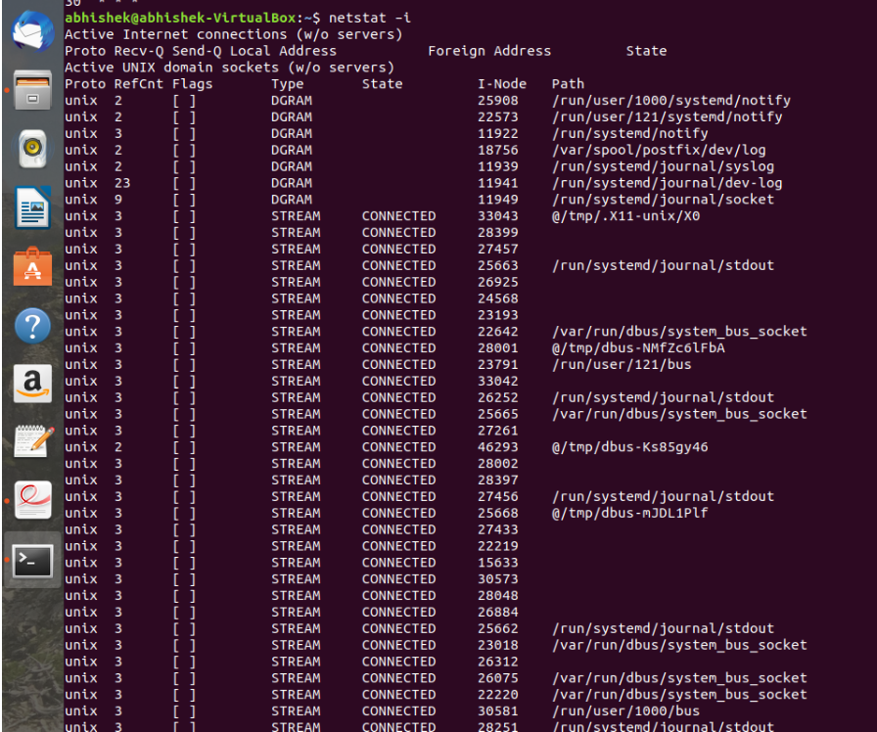

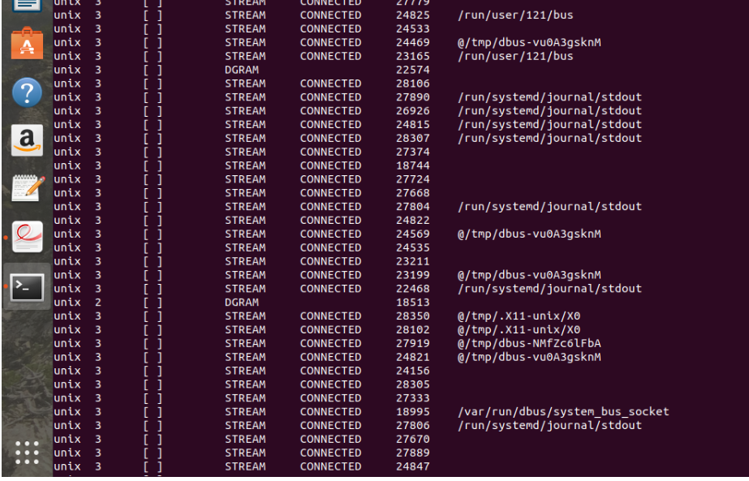

**$netstat –a**

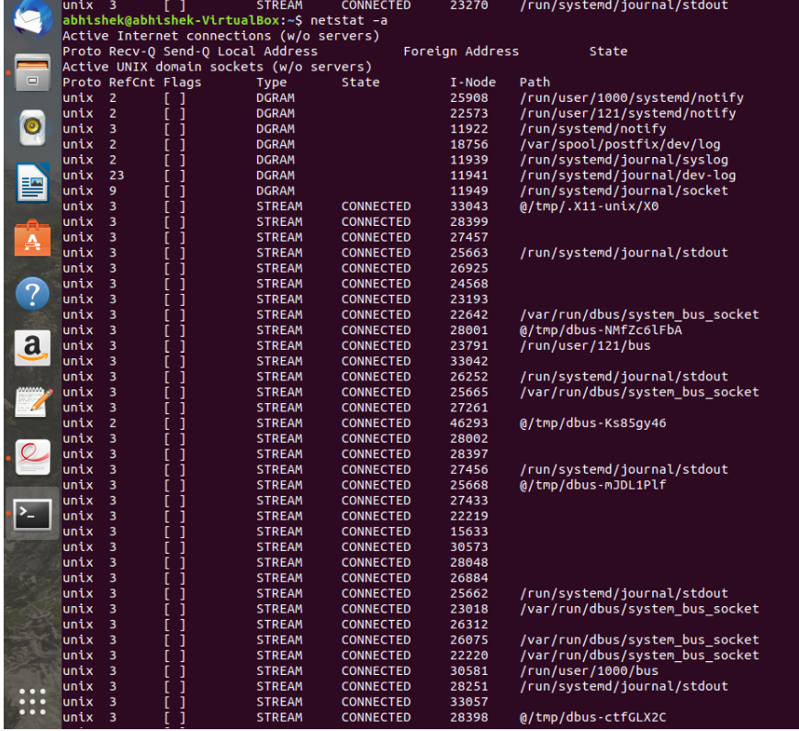

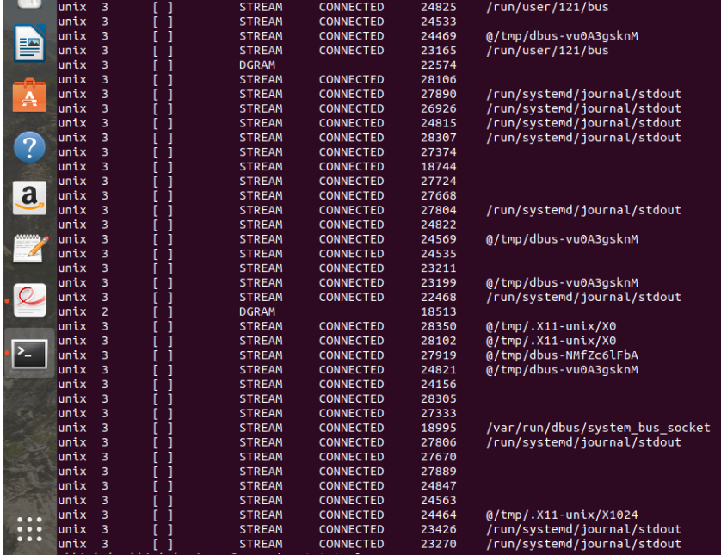

**$netstat –lp**

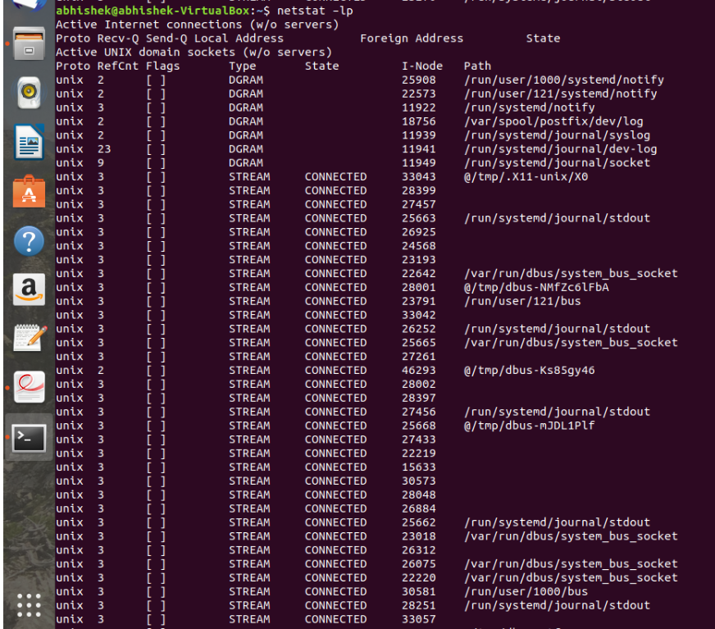

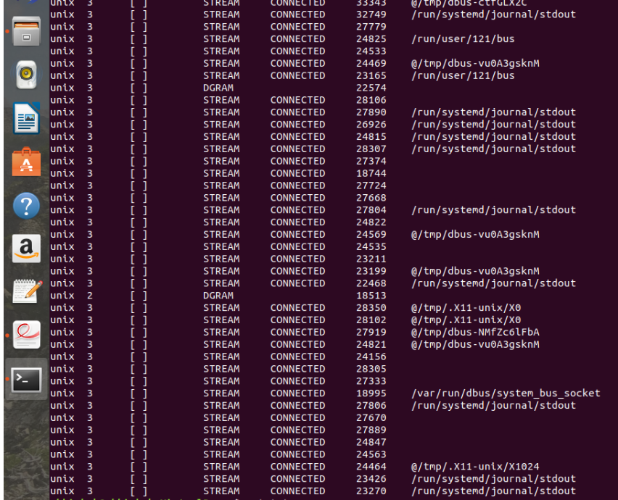

**$netstat –r**

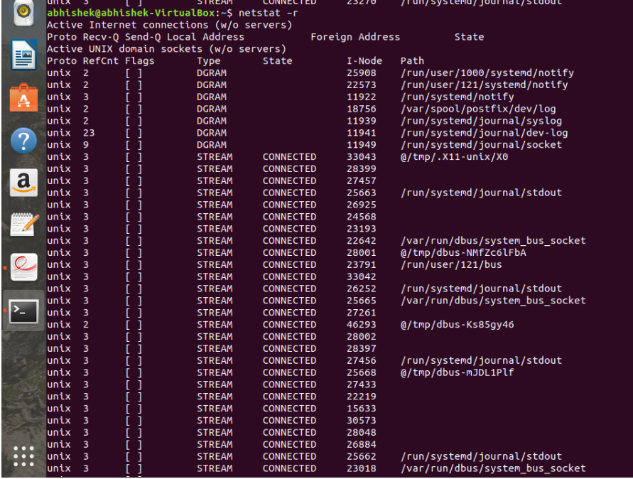

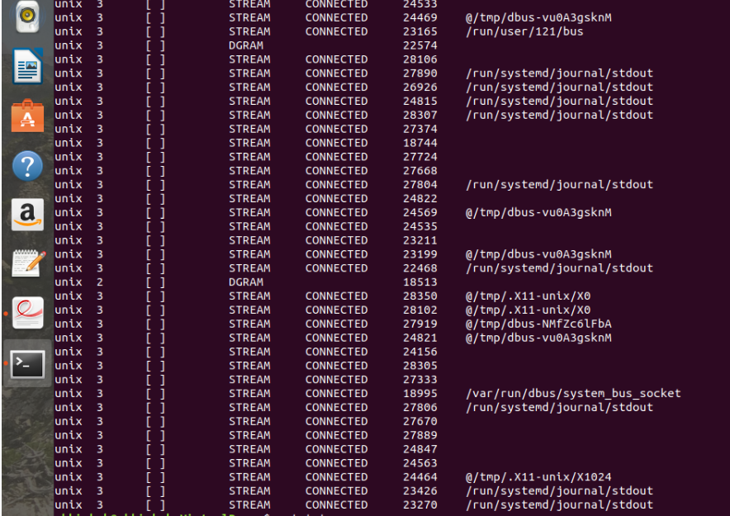

**$netstat –s**

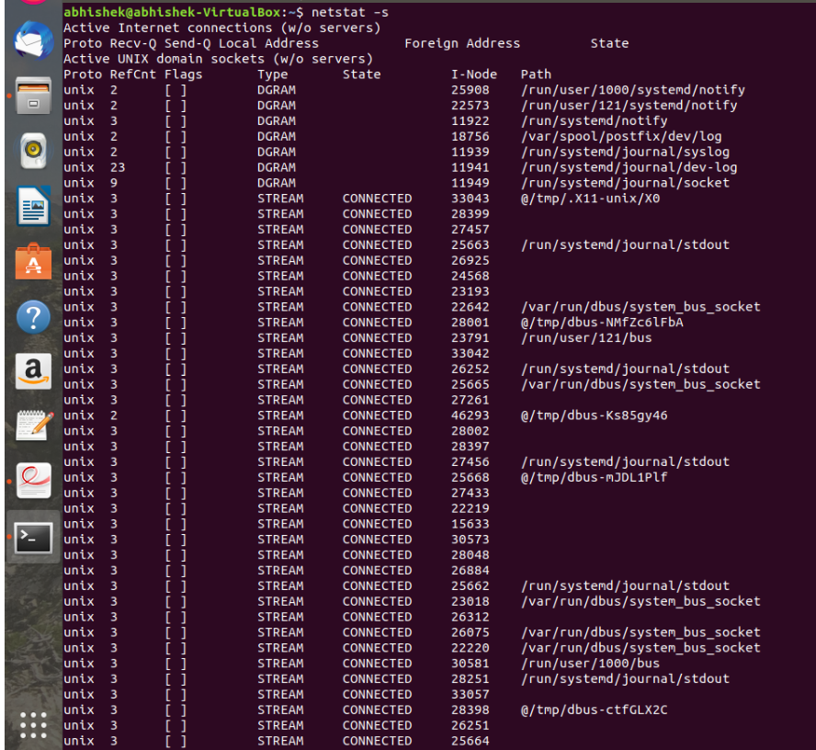

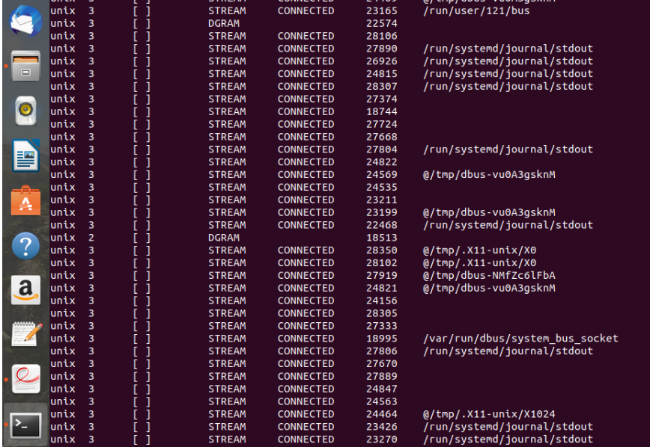

**$tcpdump host 8.8.8**

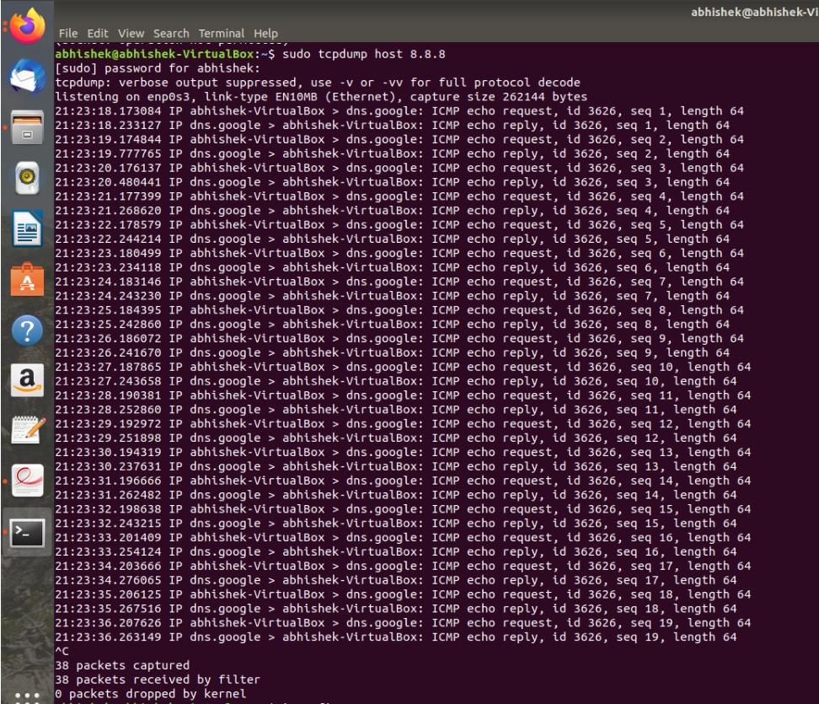

**$ping 8.8.8.8 (OPEN THIS COMMAND IN ANOTHER TERMINAL)**

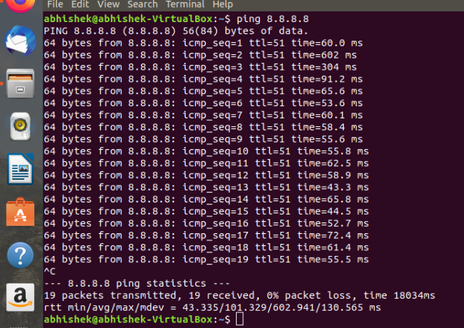

**$ifconfig**

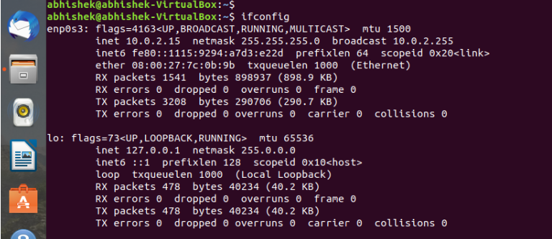

**$ sudo tcpdump -w output.dump -I enp0s3 net 10.0.2.15 and dst port 443**



**$ sudo apt-get install wireshark**

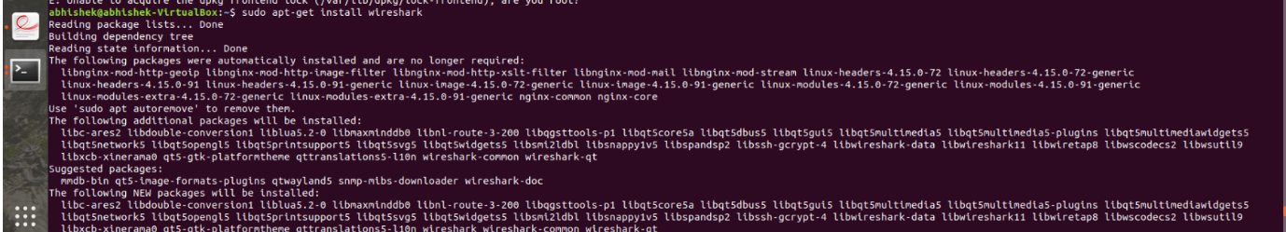

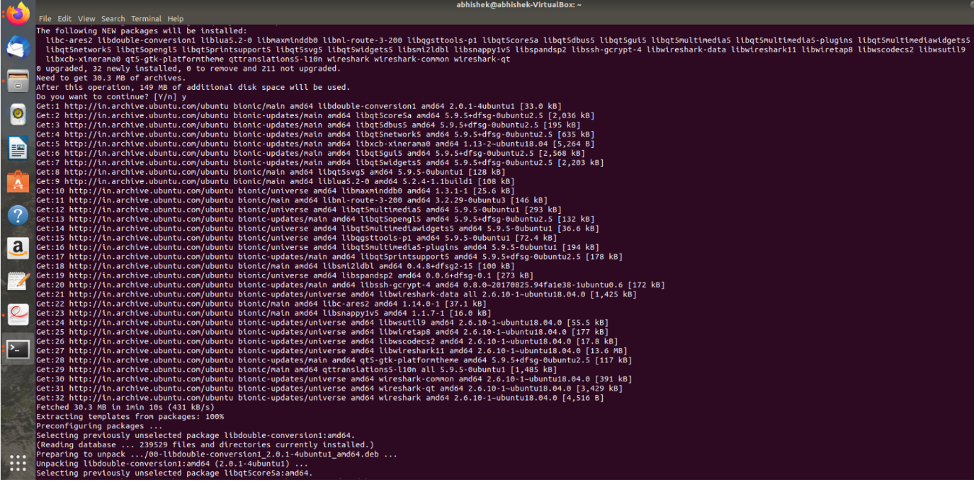

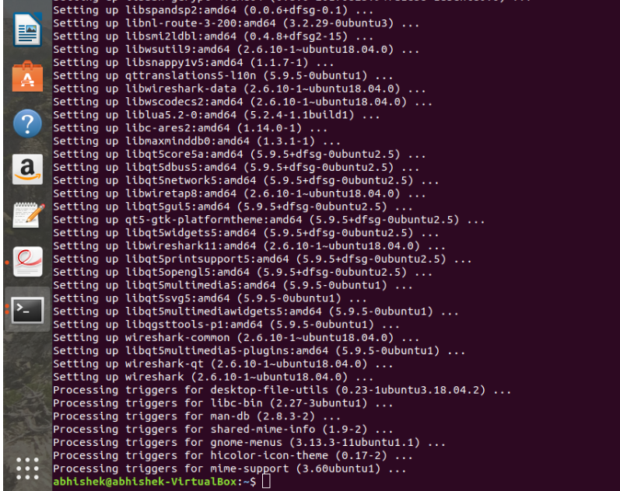

**OUTPUT: -**

